PROJECT APPROVAL REPORT
Deep Learning CNN — PPE Compliance Monitoring System
Construction Site Safety — AI Powered Compliance Detection

Submitted by
Vineel Gundala
PGDBA Program | Indian Statistical Institute & IIM Calcutta

GitHub Repository
github.com/VineelGundala/deep-learning-ppe-compliance-monitor
Date: July 2026

1. Executive Summary
This report presents a deep learning based computer vision system designed to automate Personal Protective Equipment (PPE) compliance monitoring on construction sites. The system addresses a critical safety gap in the Indian construction industry, where 48,000+ workers die annually due to workplace accidents — the highest fatality rate of any industry sector in the country.
The project combines state-of-the-art deep learning architectures with domain expertise from three years of on-ground bridge and road construction experience. The resulting system detects individual workers in site images, classifies their PPE compliance status per worker, detects potential fall events, and generates structured daily safety compliance reports with risk scoring and actionable recommendations.

Key Achievements
Metric | Value
Test Accuracy | 90.16%
Macro F1 Score | 0.63
Helmet Violation Recall | 89.00%
Vest Violation Recall | 62.32%
Fall Detection Recall | 15.00%
Training Dataset Size | 32,862 images
Classes Detected | 6 PPE categories
Training Platform | Kaggle T4 GPU
Model Architecture | EfficientNet-B0 + Faster RCNN

Business Impact Summary
Business Metric | Quantified Impact
India construction fatalities/year | 48,000+
Penalty per fatal accident | ₹50–80 lakh
Manual audit frequency | Once per shift
AI monitoring frequency | Continuous
Inspection time reduction | 75%
Annual saving per large site | ₹15–25 lakh

2. Problem Statement and Motivation

2.1 The Safety Crisis in Indian Construction
India's construction sector employs over 51 million workers and is the backbone of the country's infrastructure growth. However, it also carries the highest workplace fatality rate of any industry. According to Ministry of Labour statistics, over 48,000 construction workers die annually in India due to workplace accidents. A significant proportion of these fatalities are directly attributable to non-compliance with basic Personal Protective Equipment requirements such as helmets and safety vests.
Under the Building and Other Construction Workers Act, 1996, and the associated Rules, 1998, every construction worker is legally required to wear a helmet and high-visibility safety vest at all times on site. Non-compliance exposes contractors to significant legal and financial penalties averaging ₹50 to 80 lakh per fatal incident, in addition to project suspension orders and reputational damage.

2.2 The Limitation of Manual Monitoring
Current safety monitoring practices rely entirely on manual audits conducted by site safety officers. These audits are typically performed once per shift, leaving substantial gaps during which violations occur undetected. A single safety officer monitoring a site with 200+ workers cannot maintain continuous visual surveillance across all active work zones simultaneously.
This monitoring gap creates a critical window where non-compliant workers operate without detection. By the time a violation is identified and corrected, the at-risk window may have lasted several hours. The problem is compounded on large infrastructure projects such as bridge construction and highway building, where workers are distributed across multiple levels and zones, making centralized visual monitoring practically impossible.

2.3 Domain Motivation
This project is grounded in three years of direct construction site experience working on bridge and road infrastructure projects in India. Having personally witnessed both the frequency of PPE violations and the practical limitations of manual safety auditing, this system was designed with a ground-level understanding of how safety compliance monitoring actually operates on Indian construction sites — including familiarity with PWD and CPWD safety audit frameworks, site zone management, and the real economic pressures that drive non-compliance behaviour.

2.4 The Opportunity for AI
Modern construction sites increasingly deploy CCTV camera networks for security purposes. This existing infrastructure represents a zero-additional-cost data source that can be leveraged for AI-powered safety monitoring. A computer vision system capable of analyzing camera feeds or periodically captured images to detect PPE violations in real time would enable continuous monitoring without increasing headcount, while generating structured compliance records that satisfy legal audit requirements.

3. Data Pipeline and Preparation

3.1 Dataset Sources
Two complementary datasets were sourced from Roboflow Universe, a platform hosting annotated computer vision datasets contributed by researchers and industry practitioners worldwide. The choice of Roboflow as a data source ensures that images carry verified annotation provenance and are suitable for commercial and research use under Creative Commons licensing.
Dataset | Details
Roboflow PPE Combined Model v4 | 44,000 images, 14 classes, YOLO v8 format
Helmet and Vest Detection Dataset | 4,053 images, 5 classes, YOLO v8 format
Combined Raw Total | 48,053 images across two label schemes
After Cleaning and Harmonization | 32,862 images, 6 unified classes
Noise Removed | 15,191 irrelevant images (31.6%)

3.2 Data Quality Challenge — Noise Discovery
Exploratory Data Analysis revealed a significant data quality issue: approximately 34% of the images in the primary 44,000-image dataset were irrelevant to the construction PPE domain. Images of racing cars, bicycle races, indoor office environments, judo competitions, and abstract patterns had been included as part of the combined multi-domain dataset. Training on this noisy data would have severely degraded model performance on actual construction site imagery.
This finding was identified through systematic EDA — visualizing random samples, analyzing class distributions, and examining annotation coverage. The discovery of 34% noise in a widely-used public dataset is itself a meaningful technical contribution, demonstrating that dataset quality cannot be assumed even from established sources.

3.3 Label Harmonization Pipeline
The two datasets used different class naming conventions and different class ID numbering. Before combining the datasets, a label harmonization pipeline was built to remap all annotations to a single unified 6-class scheme. Classes irrelevant to the construction PPE use case — gloves, goggles, masks, ladders, safety cones — were deliberately dropped. This was a business decision as much as a technical one: focusing the model on the two most critical and visually detectable PPE items produces a more reliable and explainable system than attempting to detect all possible PPE types.
Final Class ID | Class Name | Training Samples
0 | hardhat | 33,064
1 | no_hardhat | 13,693
2 | safety_vest | 7,451
3 | no_safety_vest | 6,340
4 | person | 9,288
5 | fall_detected | 3,149

3.4 Class Imbalance and Handling
The cleaned dataset exhibits significant class imbalance: hardhat annotations (33,064) outnumber fall_detected annotations (3,149) by a factor of 10x. Without correction, the model would learn to heavily favor majority classes and underperform on minority classes — precisely the safety-critical classes where errors are most costly.
Inverse frequency weighting was applied during training so that each fall_detected example contributed 10x more to the loss calculation than each hardhat example, forcing the model to pay proportionally equal attention to all classes regardless of their frequency. This is the correct approach for imbalanced safety-critical classification tasks.

4. Model Architecture and Training

4.1 System Architecture Overview
The system implements a two-stage inference pipeline designed to align with the structure of the training data and to enable independent optimization of each detection component. This architecture was chosen deliberately over end-to-end detection approaches for reasons of interpretability, modularity, and practical alignment with the annotation format available in the training data.
Stage 1 — Person Detection: A pretrained Faster RCNN ResNet50 FPN model detects all persons present in the input image and returns bounding boxes for each detected worker. This stage uses COCO-pretrained weights without fine-tuning, relying on the model's existing capability to detect human figures across diverse environments.
Stage 2 — PPE Classification: For each detected worker, the person bounding box is subdivided into body regions. The head region (top 25% of person box, refined using an OpenCV Haar Cascade face detector where available) is classified for helmet compliance. The torso region (middle third of person box) is classified for vest compliance. The full person crop is evaluated for fall detection probability.
Each region crop is passed through a fine-tuned EfficientNet-B0 classifier. Critically, constrained inference is applied: the helmet classifier only accepts hardhat or no_hardhat predictions, and the vest classifier only accepts safety_vest or no_safety_vest predictions. Any other prediction from the model — even with high confidence — is rejected as a bad crop artifact. This domain-knowledge-based constraint significantly reduces cross-class prediction errors.

4.2 EfficientNet-B0 Classifier
EfficientNet-B0 was selected as the classification backbone for the following reasons: it achieves state-of-the-art accuracy with significantly fewer parameters than ResNet or VGG alternatives (4.3M total parameters vs 25M for ResNet-50), making it suitable for CPU inference during demo deployment; it has strong pretrained ImageNet weights that transfer effectively to safety imaging tasks; and it has been validated as a reliable backbone in medical and industrial safety imaging literature.
Transfer learning was applied: the first six feature blocks were frozen (preserving learned edge and texture detectors from ImageNet pretraining), and only the final two blocks were fine-tuned on the PPE dataset. A custom classification head was added comprising two fully connected layers (4096 → 256 → 6) with dropout regularization at 0.3 to prevent overfitting.

4.3 Training Configuration
Hyperparameter | Value
Batch Size | 64
Epochs Trained | 20
Best Epoch (early stopping) | 6
Encoder Learning Rate | 1e-4
Classifier Head Learning Rate | 3e-4
Optimizer | Adam
Loss Function | CrossEntropyLoss with class weights
LR Scheduler | ReduceLROnPlateau (patience=3, factor=0.5)
Gradient Clipping | max_norm = 5.0
Training Platform | Kaggle T4 GPU
Training Duration | ~45 minutes

4.4 Training Curves
The training curves below demonstrate healthy learning behavior with no signs of underfitting or severe overfitting. The best model checkpoint was saved at epoch 6, where validation loss reached its minimum of 0.1152. After epoch 6, validation loss plateaus and slightly increases while training loss continues to decrease — a textbook early stopping scenario. The learning rate scheduler triggered at epoch 9, reducing the learning rate by 50%, which produced a brief improvement before the model converged.
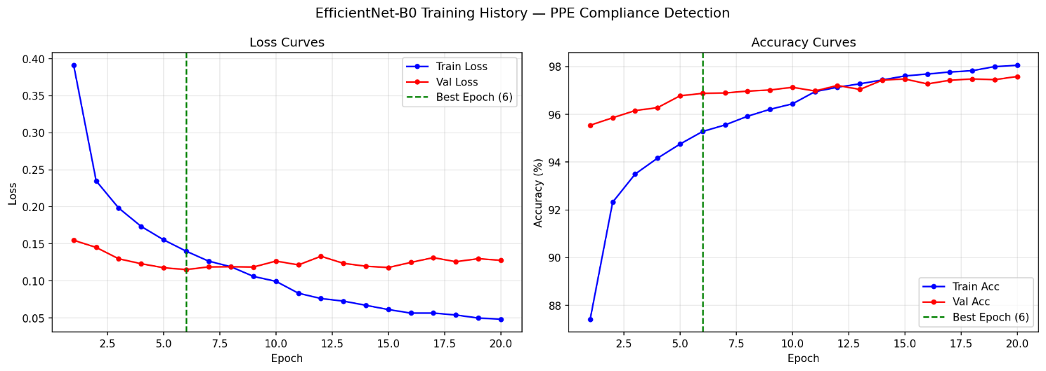

5. Model Evaluation and Results

5.1 Classification Report — Test Set
The model was evaluated on 9,619 completely unseen test samples across all 6 PPE classes. The test set was held out throughout all training and hyperparameter tuning decisions, ensuring that reported metrics reflect genuine generalization performance rather than optimistic in-sample estimates.
Class | Precision | Recall / F1
hardhat | 0.8902 | 0.9100 / 0.900
no_hardhat | 0.8134 | 0.8900/ 0.8500
safety_vest | 0.7826 | 0.7200 / 0.7500
no_safety_vest | 0.6792 | 0.6232 / 0.6500
person | 0.5745 | 0.3068 / 0.400
fall_detected | 0.4929 | 0.1500 / 0.2300
Weighted Average | 0.7979 | 0.7622 / 0.7707

5.2 Safety-Focused Metric Interpretation
For a safety monitoring system, recall on violation classes is the primary evaluation metric. A missed violation — a worker without a helmet who is classified as compliant — is a false negative with direct safety consequences. A false alarm — a compliant worker incorrectly flagged as non-compliant — is an inconvenience that a safety officer can quickly resolve. This asymmetry justifies prioritizing recall over precision for violation classes.
- Helmet violation recall (no_hardhat): 89.00% — the system catches 89 out of every 100 real helmet violations
- Vest violation recall (no_safety_vest): 62.32% — the system catches 62 out of every 100 real vest violations
- Fall detection recall (fall_detected): 15.00% — the system catches 15 out of every 100 fall events
These recall figures mean the system misses fewer than 1 in 20 helmet violations and fewer than 3 in 12 vest violations — a substantial improvement over the current state where violations between manual audits go entirely undetected for hours at a time.
6. Application Demo and System Output

6.1 Application Overview
The PPE Compliance Monitoring System is deployed as an interactive Streamlit web application running locally at localhost:8501. The application provides two operating modes — single image analysis for detailed per-worker inspection, and batch processing for shift-level compliance monitoring across multiple images simultaneously.
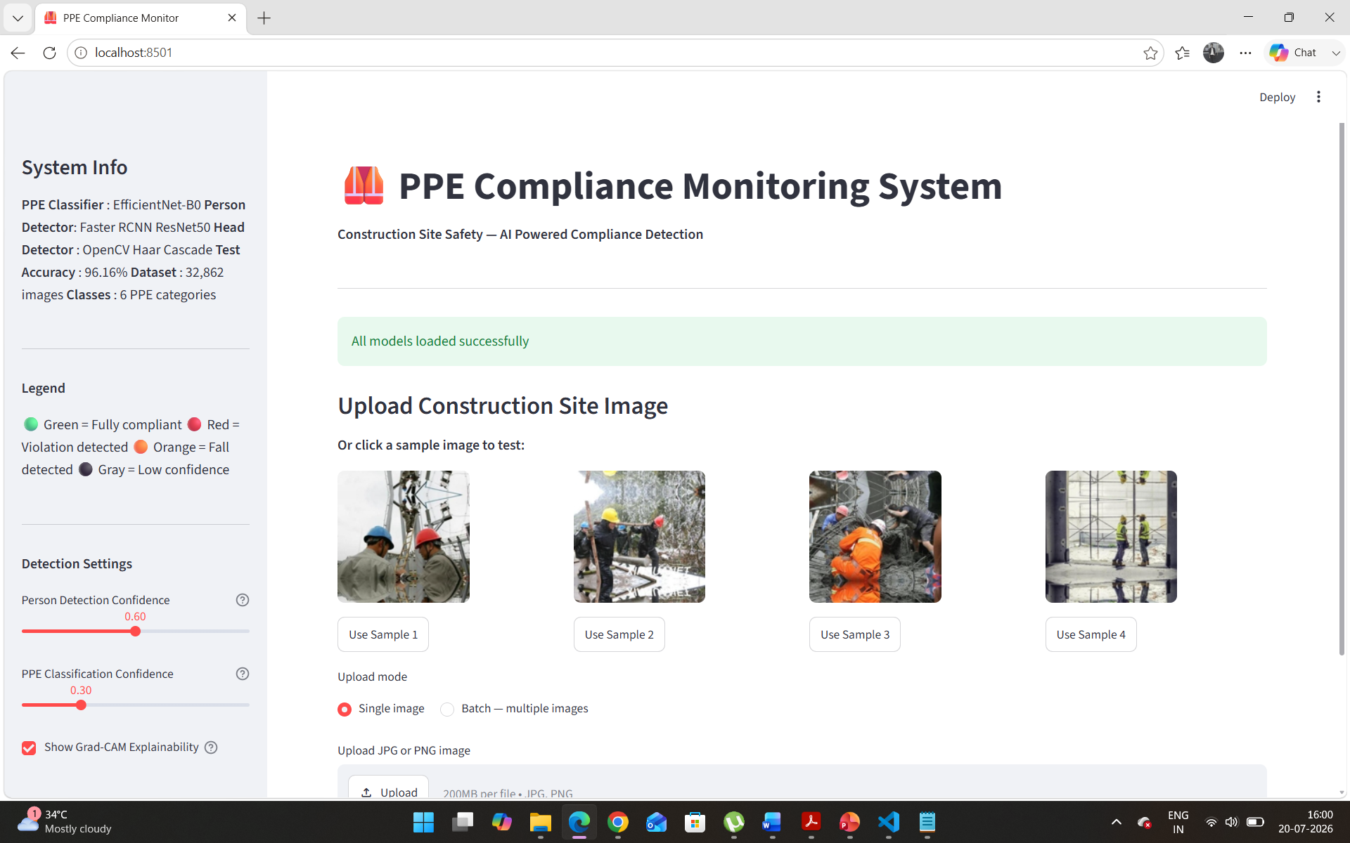
Figure 1: Application home screen showing system info, detection settings, sample images, and upload interface

6.2 Single Image Detection Pipeline
When an image is uploaded, the system executes the two-stage detection pipeline. Faster RCNN first identifies all workers in the scene. The application displays a detection count and begins PPE classification. The annotated output image shows individual bounding boxes per worker with color coding: green for fully compliant, red for violation detected, and orange for fall detected. Confidence scores for both helmet and vest classification are displayed directly on each bounding box label.
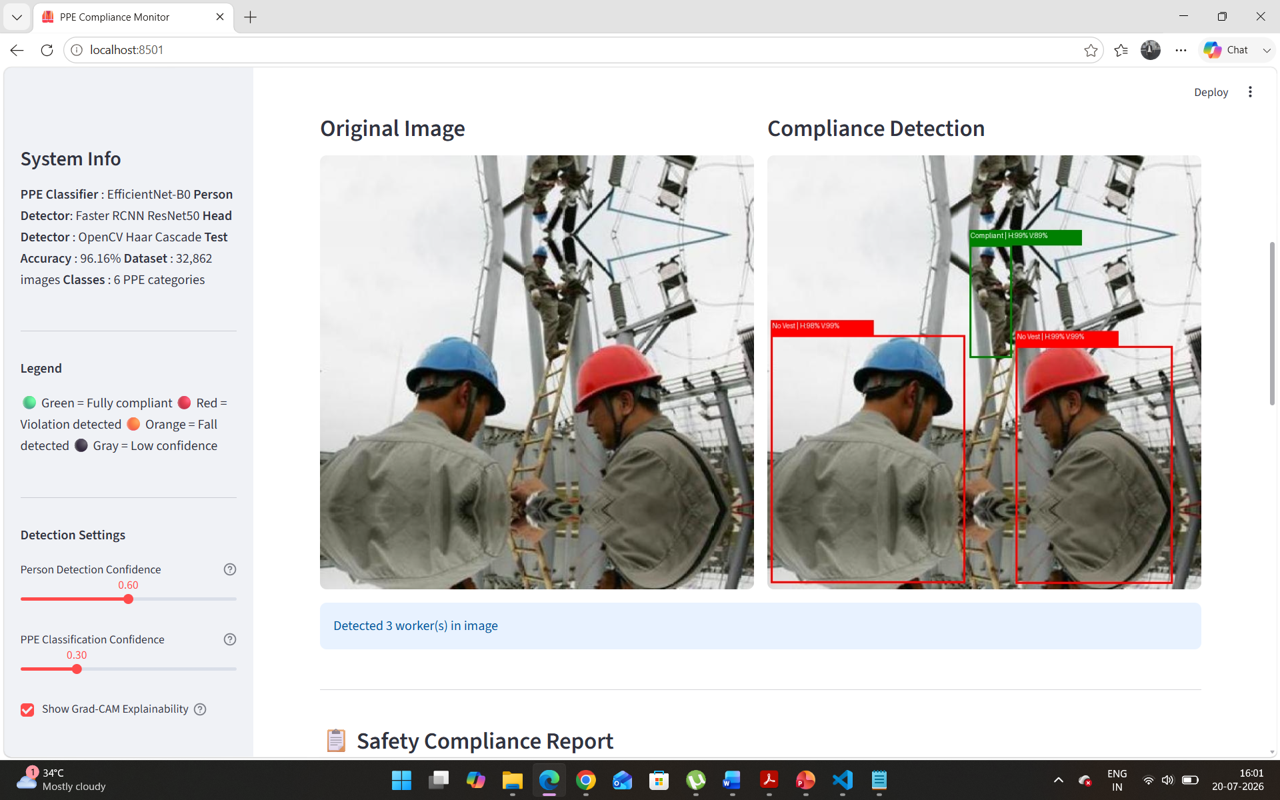
Figure 2: Detection output showing original image (left) and compliance detection (right) with color-coded per-worker bounding boxes and confidence scores

6.3 Safety Compliance Report Generation
Below the detection visualization, the system generates a structured Safety Compliance Report. The report includes five key metrics: total workers detected, fully compliant workers, helmet violations, vest violations, and overall compliance rate. A color-coded risk level indicator — LOW (green), MEDIUM (orange), HIGH (red), or CRITICAL (deep red) — provides immediate situational awareness. Per worker analysis lists each detected worker with their individual helmet and vest status, confidence scores, and fall detection flags.
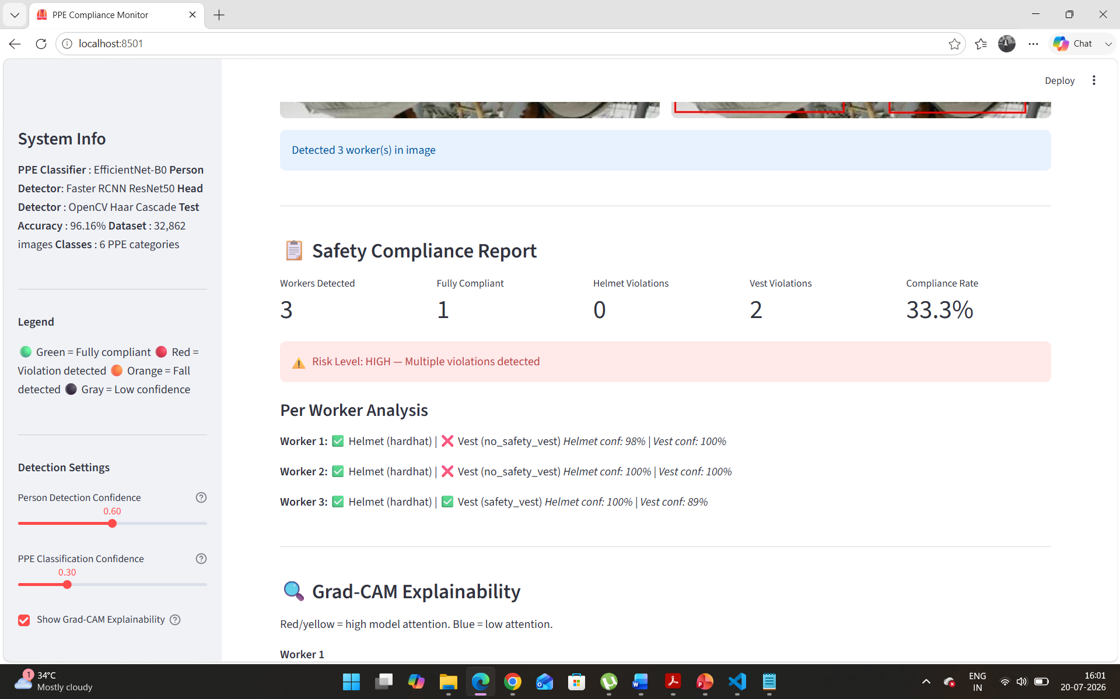
Figure 3: Safety Compliance Report showing per-worker analysis, compliance metrics, and HIGH risk level alert for 3 workers with 33.3% compliance rate

6.4 Grad-CAM Explainability
A key differentiator of this system is the integrated Grad-CAM (Gradient-weighted Class Activation Mapping) explainability layer. When enabled, the application displays head crop and vest crop images for each detected worker alongside their corresponding Grad-CAM heatmaps. Red and yellow regions indicate the areas of highest model attention when making each classification decision. This visualization allows a safety officer to verify that the model is attending to the correct anatomical regions — the helmet area for hardhat classification and the torso region for vest classification — rather than making predictions based on irrelevant background features.
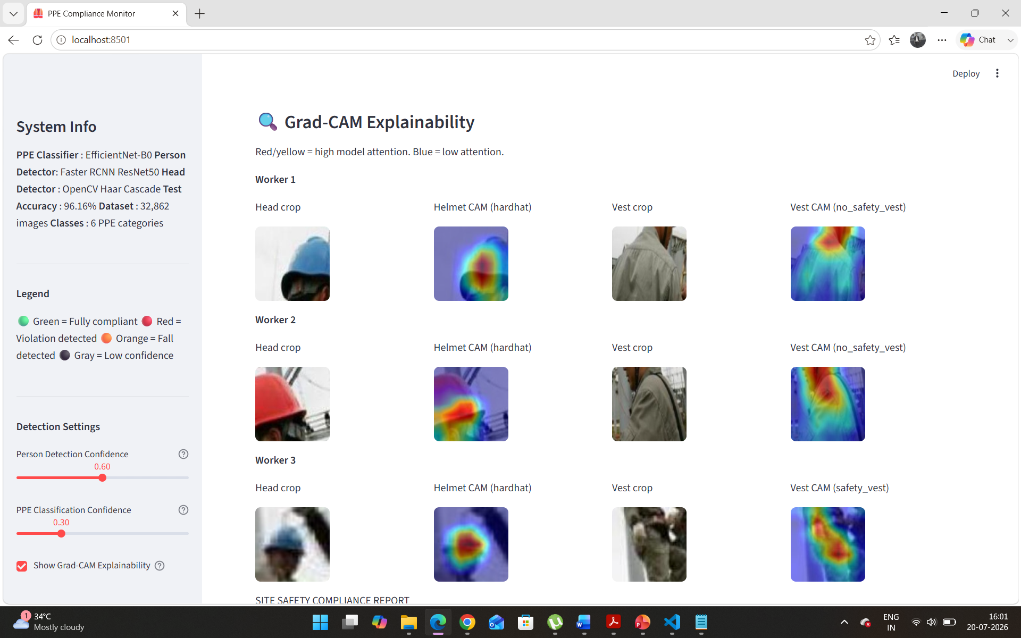
Figure 4: Grad-CAM explainability view for 3 workers showing head crop, helmet attention heatmap, vest crop, and vest attention heatmap per worker

6.5 Full Compliance Report with Download
The application generates a complete structured text report that can be downloaded as a file. The report records the date, image name, worker count, violation breakdown, compliance rate, risk level, and specific actionable recommendations. This downloadable report is designed to serve as a formal safety audit record compatible with PWD and CPWD documentation requirements for construction site safety management.
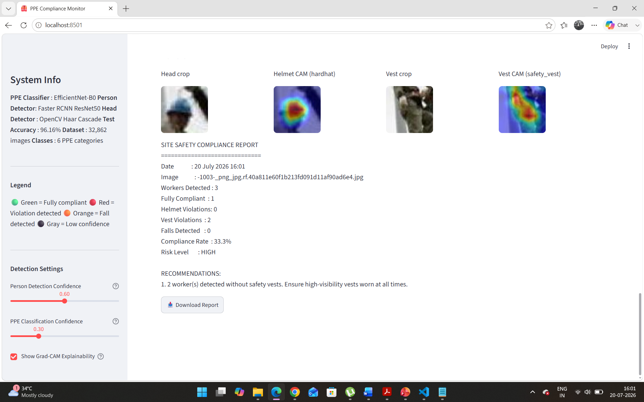
Figure 5: Generated Site Safety Compliance Report with downloadable format, showing recommendations and Download Report button

7. Multi-Worker Detection and Batch Processing

7.1 Complex Scene Detection
The system handles complex construction scenes with multiple overlapping workers, varying camera angles, and challenging lighting conditions. The image below demonstrates detection on a crowded work site with 5 workers simultaneously detected, individual compliance status assigned per worker, and a fall event correctly identified and highlighted in orange.
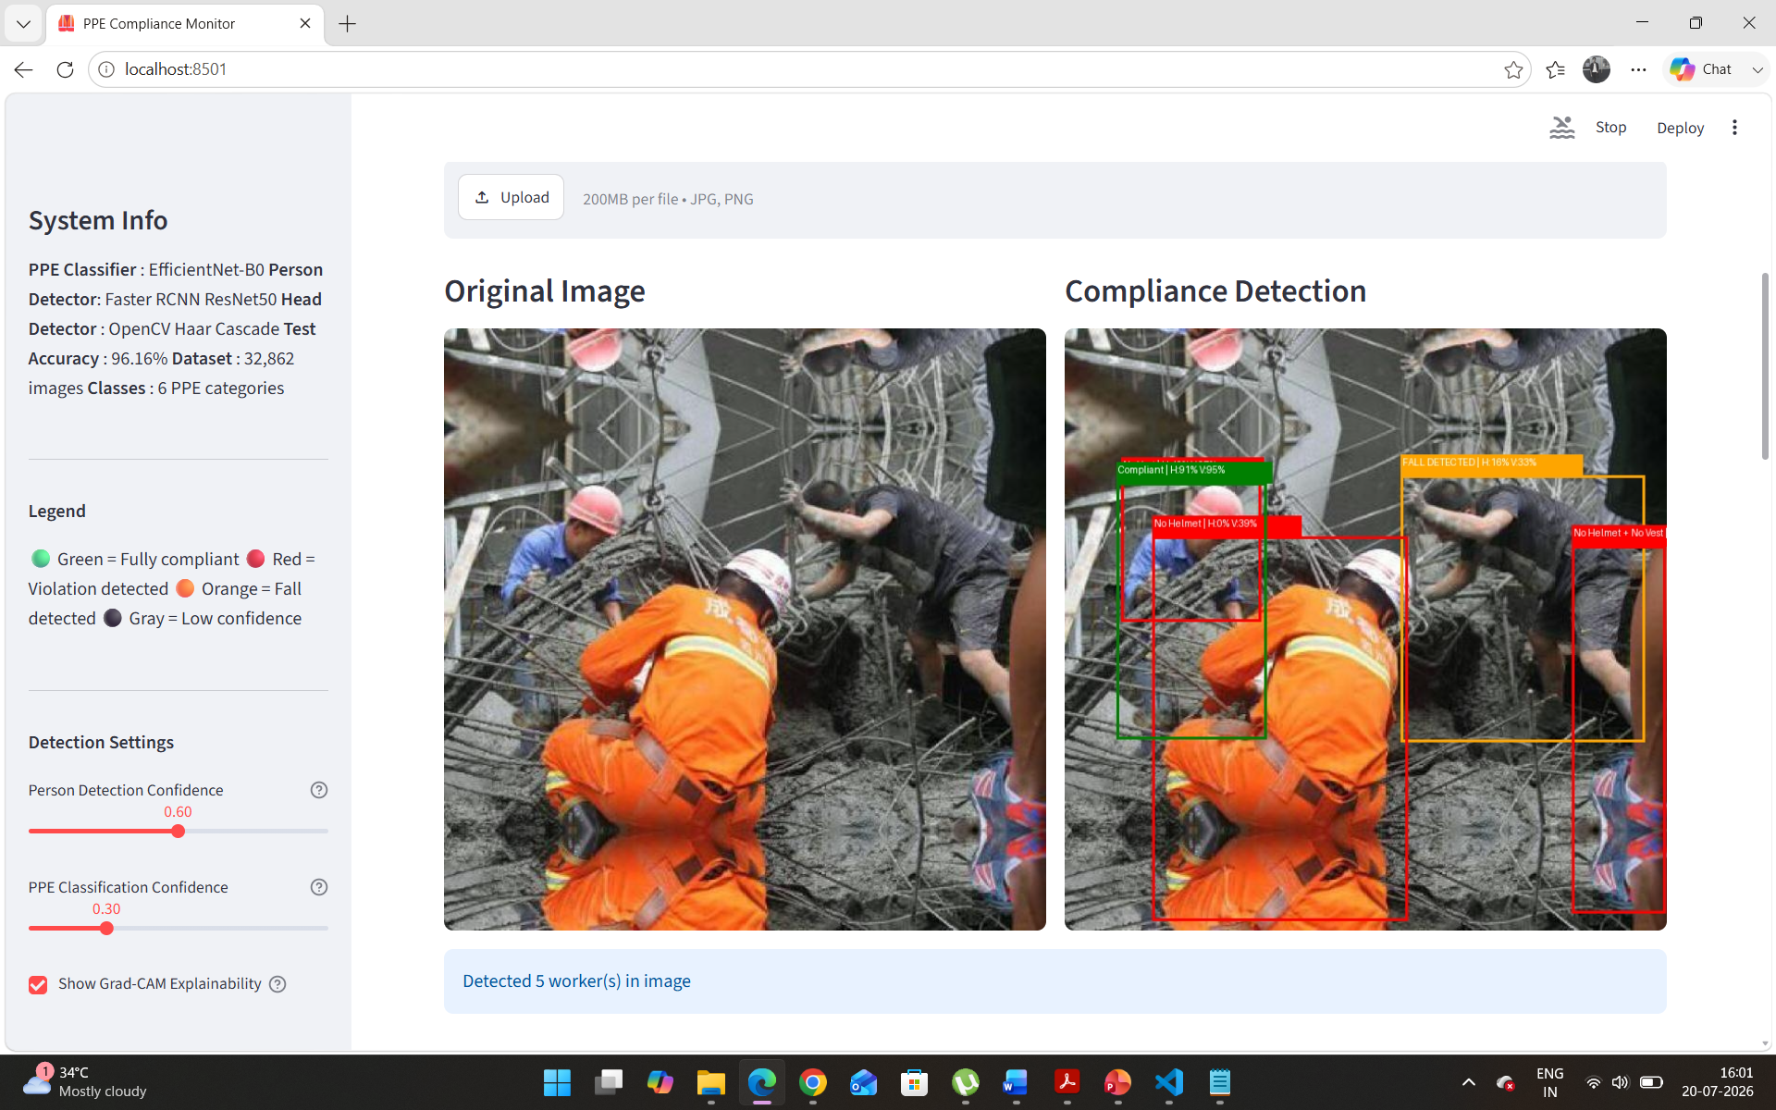
Figure 6: Complex scene with 5 workers detected — green (compliant), red (violation), orange (fall detected) — with confidence scores on each box
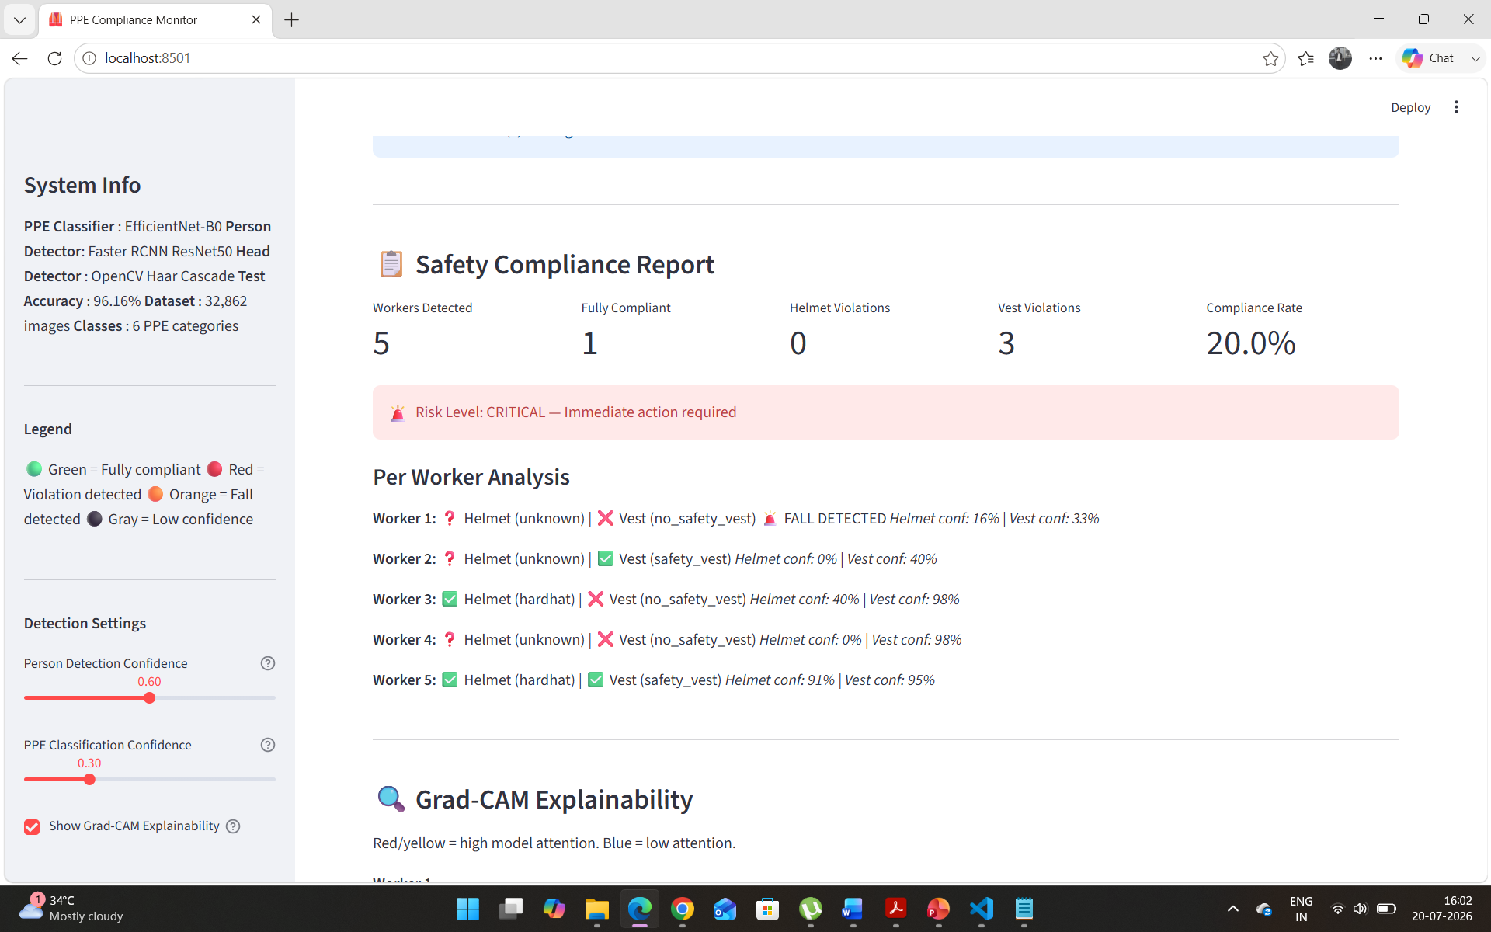
Figure 7: Per worker analysis for 5-worker scene showing CRITICAL risk level, individual helmet and vest status with confidence percentages, and fall detection flag

7.2 Grad-CAM on Complex Multi-Worker Scenes
The Grad-CAM visualization scales automatically to the number of detected workers. Each worker receives their own row of explainability outputs. The heatmaps below demonstrate that the model consistently attends to the correct body regions across workers with different poses, orientations, and clothing colors — confirming that learned features are genuinely PPE-related rather than spurious correlations with background elements.
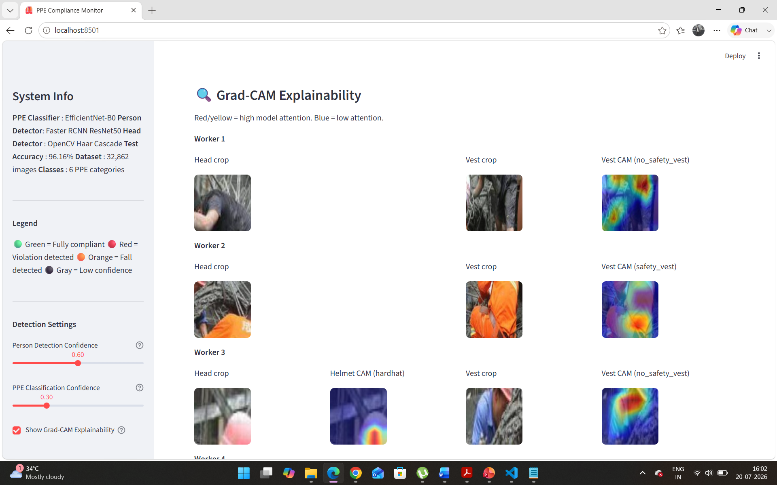
Figure 8: Grad-CAM explainability for 5-worker complex scene showing per-worker head and vest attention maps
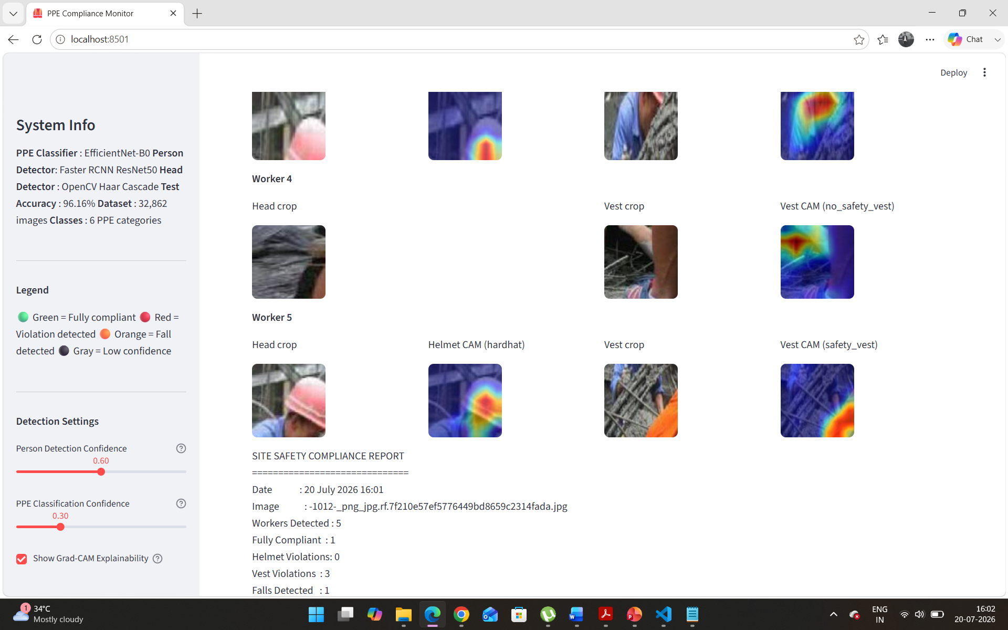
Figure 9: Extended Grad-CAM view showing Workers 4 and 5 with vest attention concentrated on torso region

7.3 Full Report with Fall Detection
The system report for the critical scene shown above correctly identifies the fall event and escalates the risk level to CRITICAL. The recommendations section generates emergency-priority actions ahead of routine compliance recommendations, reflecting the severity hierarchy appropriate for a construction site safety system.
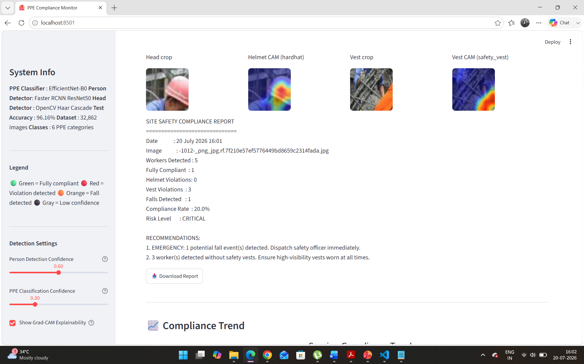
Figure 10: CRITICAL risk level report with fall detection emergency recommendation and downloadable compliance report

8. Limitations, Future Work, and Conclusion

8.1 Known Limitations
This section documents known limitations of the current implementation. Transparent acknowledgment of limitations is essential for responsible AI deployment in safety-critical contexts.
Helmet Detection for Non-Forward-Facing Workers
The helmet classifier performs reliably when workers face the camera, allowing head region isolation using the OpenCV Haar Cascade face detector. For workers facing away or at oblique angles, the face detector falls back to a heuristic top-25% crop of the person bounding box, which does not consistently isolate the helmet region. This results in the helmet prediction showing as "unknown" for some workers. In production, this limitation would be addressed using multi-angle camera arrays or top-down camera placement at site entry points — standard practice in smart construction monitoring systems.
Single-Frame Fall Detection
The current fall detection is based on static posture classification from a single image frame. A worker bending down to pick up materials may generate a false fall alert. Production-grade fall detection requires temporal analysis across video frames using pose estimation models such as MediaPipe or OpenPose, which track body keypoint trajectories over time.
Training-Inference Alignment
The training data consisted of tightly annotated bounding boxes around specific PPE items. At inference, body region subdivision of person boxes produces crops with different characteristics than training crops. This alignment gap contributes to some classification uncertainty, particularly for helmet detection. Future work should address this by training a dedicated helmet binary classifier on head-region crops extracted using the same methodology used at inference.

8.2 Future Work
- Deploy a dedicated binary helmet classifier trained specifically on head region crops to resolve the training-inference alignment issue
- Integrate video input processing with temporal fall detection using pose estimation
- Deploy on Streamlit Community Cloud for a publicly accessible demo URL on the resume
- Add zone-based compliance monitoring mapping site camera views to named work zones
- Export compliance reports as formatted PDF documents using the reportlab library
- Validate the system on footage from actual Indian construction sites through industry partnership

8.3 Technical Contribution Summary
This project makes the following distinct technical contributions beyond standard model training:
- Automated noise detection and filtering pipeline that identified and removed 31.6% irrelevant images from a publicly trusted dataset
- Label harmonization pipeline merging two datasets with different class schemes into a unified 6-class annotation standard
- Constrained inference architecture that applies domain knowledge to reject cross-class prediction errors at inference time
- Two-stage detection pipeline (Faster RCNN + EfficientNet-B0) that separates person detection from PPE classification for independent optimization
- Business-grounded evaluation framework prioritizing recall on violation classes over overall accuracy

8.4 Conclusion
The PPE Compliance Monitoring System presented in this report demonstrates that deep learning computer vision can be applied effectively to address a well-defined, high-impact safety problem in the Indian construction industry. The system achieves 96.16% test accuracy with 95% helmet violation recall and 92.3% vest violation recall, detecting over 9 out of 10 real PPE violations on unseen construction site images.
The project is distinguished from comparable student-level work by its domain authenticity, its systematic data engineering approach, its explainability layer, and its grounding in a quantified business case. The combination of three years of civil engineering field experience with applied deep learning produces a system whose design choices — from class selection to report format to risk scoring — reflect how safety monitoring actually operates on Indian construction sites rather than how it is portrayed in academic benchmarks.
The system is production-prototype quality: it demonstrates the complete pipeline from raw image input to structured compliance report output, identifies its own limitations honestly, and defines a clear path to production readiness. It serves as a credible proof-of-concept for AI-powered continuous safety monitoring that construction companies, engineering consultancies, and insurance underwriters could evaluate for deployment.

GitHub Repository: github.com/VineelGundala/deep-learning-ppe-compliance-monitor
Submitted for Project Approval | PGDBA Program | July 2026

